LYCEUM OF THE PHILLIPINES UNIVERSITY – CAVITE
COLLEGE OF ENGINEERING
Elective 2 (Web Application Development)

CONDITIONAL STATEMENTS IN PHP

SCORE/GRADE

Student Name (LN, FN, MI) | GUARINO, JESSIE JR, A.
Date Assign | October 16, 2025
Date of Submission | November 4, 2025
Course Code / Section | ECPN02E / CPE401

INSTRUCTIONS:

- After you are done performing this activity, kindly create a short video that will show yourself and your output (webpage design). In case you will not be able to comply all the requirements needed, just take a video for your current accomplished webpages only.
- Kindly submit your short video in the link provided by your teacher.
- No late submission will be accepted and checked.
- Kindly do your own work. You can ask your classmates but definitely do not copy.
- The main goal of this activity is not just to accomplish the task, but to learn something in webpage designing.

- OBJECTIVES
At the end of this laboratory, student should be able to:
  - Explore and understand conditional statements in PHP programming language.
  - Incorporate conditional statements in PHP in an actual web development.
  - Develop web application where conditional statements applied in an actual scenario.

- MATERIALS
- Computer Set
- VS Code
- XAMPP
- https://www.w3schools.com/html/default.asp
- https://www.w3schools.com/css/default.asp
- https://www.w3schools.com/bootstrap/bootstrap_ver.asp

- PROCEDURES

Problem:
Create a simple payroll web application that will compute the gross income and net income of an employee with the following specification:
  - As a programmer, you are allowed to create your own interface design based on your own likes, however, all required fields shown in Payroll webpage design under laboratory activity 2 should be present.
  - You can use the payroll webpage designed under PAYROLL - Laboratory 2.
  - To comply with the requirements needed, consider the given computation requirements below:

    - Basic Income:
Income / Cut Off = rate_per_hour * num_of_hours_cutoff

    - Honorarium Income:
Income / Cut Off = rate_per_hour * num_of_hours_cutoff

    - Other Income:

Income / Cut Off = rate_per_hour * num_of_hours_cutoff

    - Gross Income:
Gross Income = basic_income_cutoff + honorarium_income_cutoff +
other_income_cutoff

    - Regular Deductions:
SSS Contribution, PhilHealth Contribution, Income Tax Contribution are coming from the actual contributions mandated by the law. Kindly refer to the given figure below for the deductions, and Pagibig Contribution is fixed with a value of 100.00.

    - Total Deductions:
Total Deductions = add all input data under Regular Deductions and Other
Deductions

    - Net Income:
Net Income = Gross Income – Total Deductions
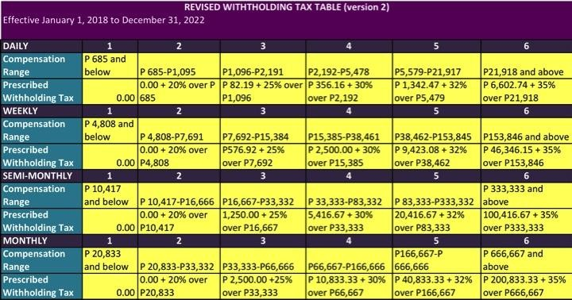

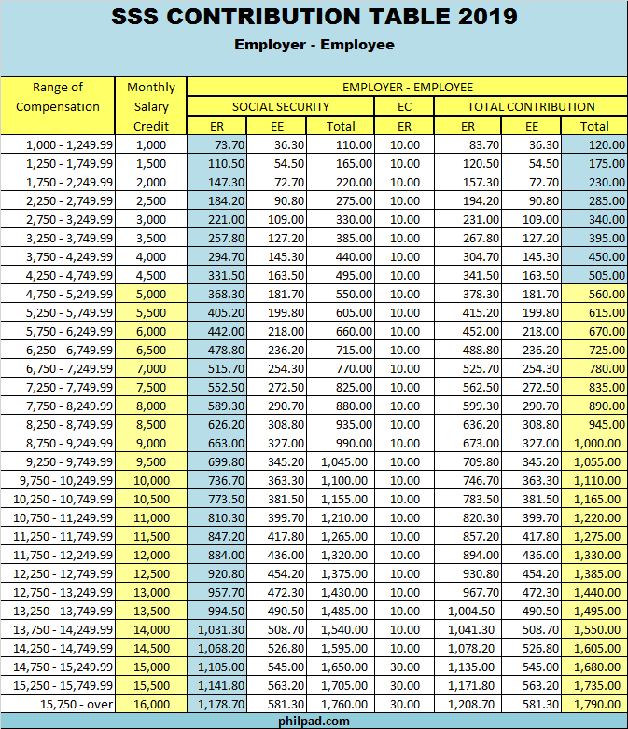

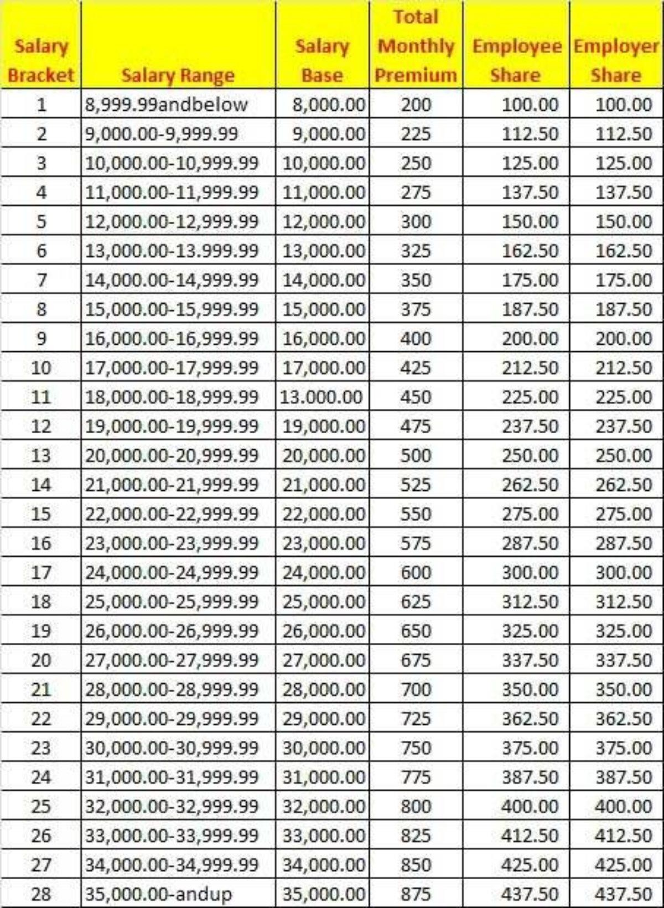

NOTE: YOU CAN DOWNLOAD THIS CONTRIBUTION TABLES IN GOOGLE.

  - When GROSS INCOME button clicked, computation results for Income / Cut Off under basic, honorarium, other income, and regular deductions will be displayed in their corresponding input text or textboxes. In addition, all data entry inputted by the user before clicking the CALCULATE GROSS INCOME button will remain displayed in their corresponding textboxes also.

  - When NET INCOME button clicked, computation results for Total Deduction, and Net Income will be displayed in their corresponding input text or textboxes. In addition, all data displayed after clicking the Calculate Gross Income button will remain, and the data entry inputted by the user in Other Deductions input text will also display in their corresponding textboxes.

  - When the NEW button clicked, all input textboxes will be empty.

  - The whole scenario of this application is shown below.

    - Run your application using your URL. If you created your own design, make it sure that all field from the original given design are covered as shown below:
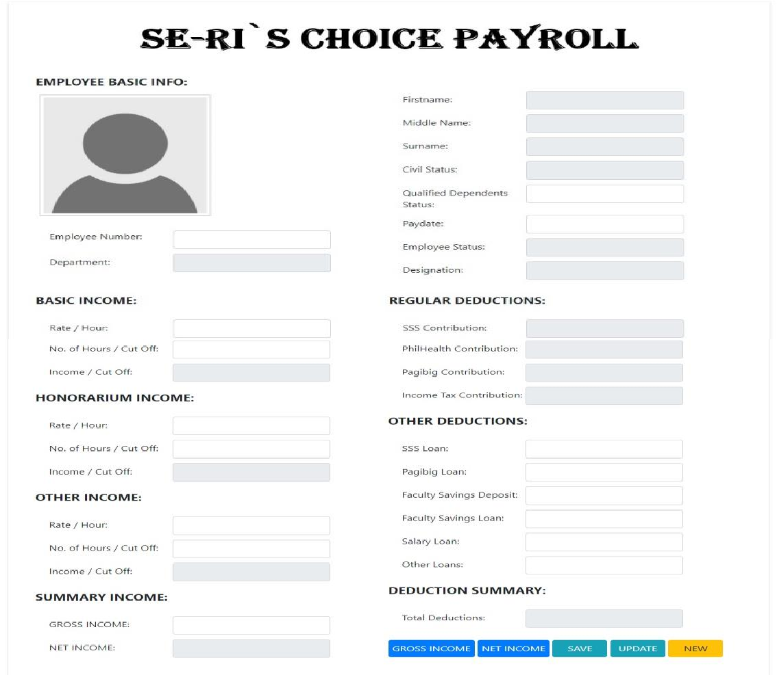

    - Input data to the following input textboxes shown in the given figure below:
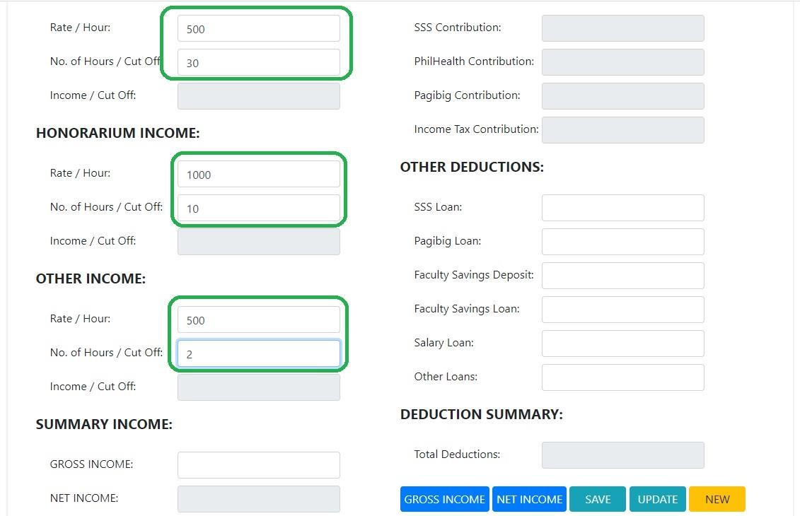

    - After doing step b, click GROSS INCOME button.
    - After clicking the gross income button, computed results for Basic Income, Honorarium Income, Other Income, Gross Income, SSS contribution, PhilHealth contribution, Pagibig, and Income Tax contribution will display on their corresponding input textbox which is shown in the given figure below.

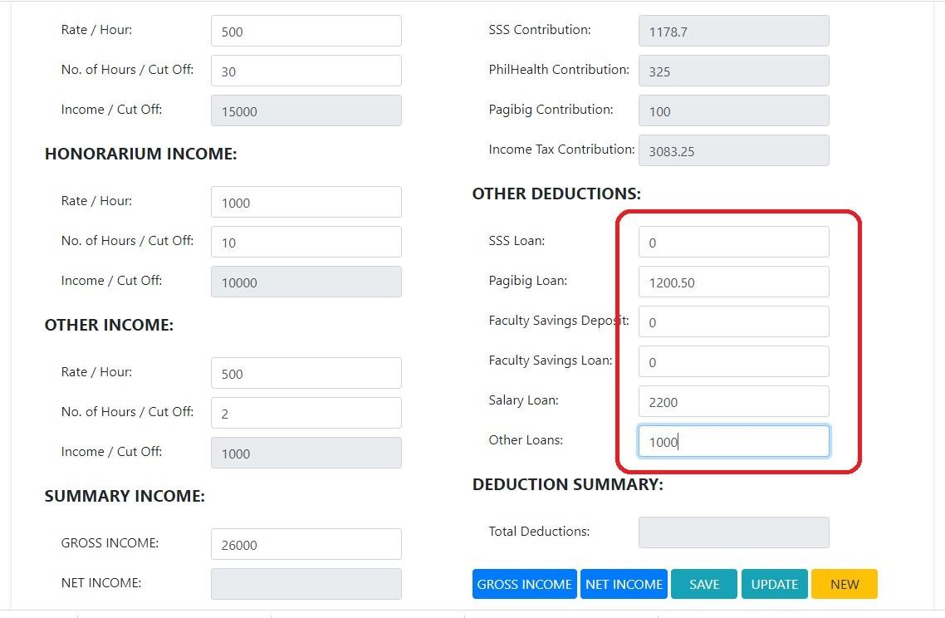
    - Input data inside the textboxes, in Other Deductions as shown in the given figure below:
    - After doing step e, click the NET INCOME button and the computed net income and total deduction will display in their respective textbox as shown in the given figure below:
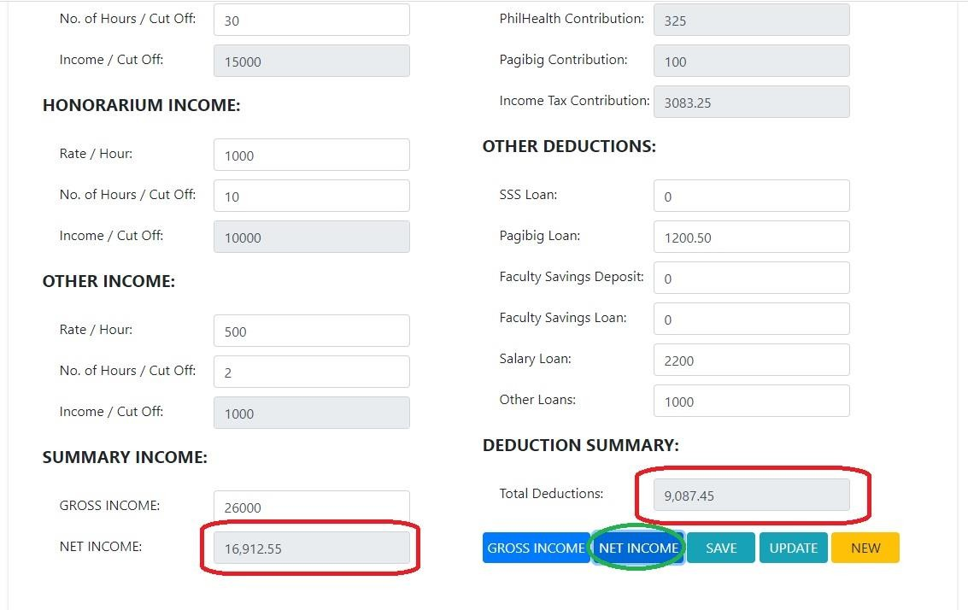

    - Then, click the NEW button. After clicking the new button, all data in textboxes will be deleted or empty and ready for the next employee payroll transaction, as shown below:
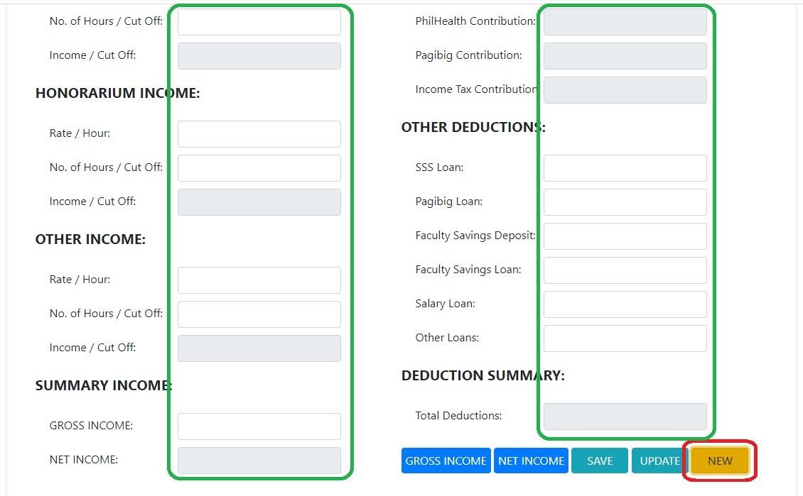

- DISCUSSION
  - As a programmer, when do we need to use or apply conditional statements?

  - What is the purpose of function in PHP? When and why are we going to apply function in our scripts?

.

  - In web development, when should we put comments in our scripts?

.

  - Discuss If-Else conditional statement.

.

  - Discuss If-Else conditional statement.

.

  - Discuss If-Else-ElseIf or nested If Else conditional statement.

.

  - Discuss Switch conditional statement.

.

  - Differentiate switch to nested if else conditional statement.

.

- OBSERVATION

- CONCLUSION

- RECOMMENDATION

- REFERENCES

